**Assignment 1 : Simple SQL Query with a single table with where clause**

1. **Write a query to get a Product list (id, name, unit price) where current products cost less than $20.**

select ProductID, ProductName,UnitPrice from Products where ((UnitPrice<20))

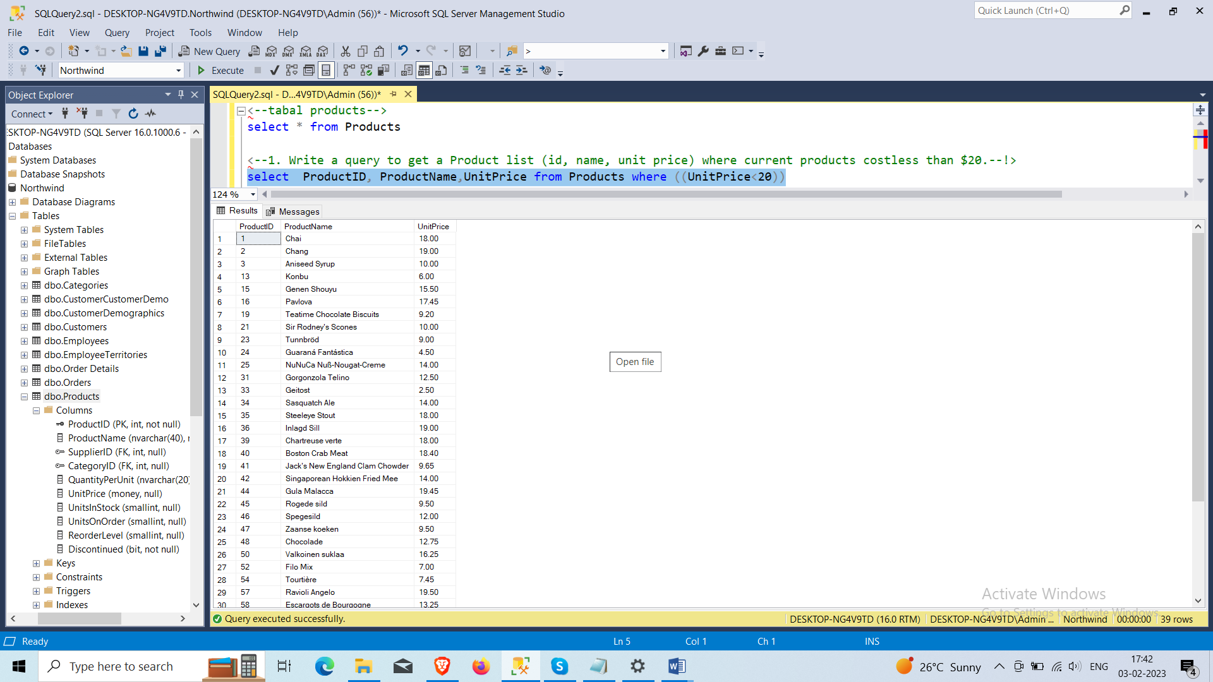

1. **Write a query to get Product list (id, name, unit price) where products cost between $15 and $25.**

select ProductID, ProductName,UnitPrice from Products where (((UnitPrice)>=15 and (UnitPrice)<=25))

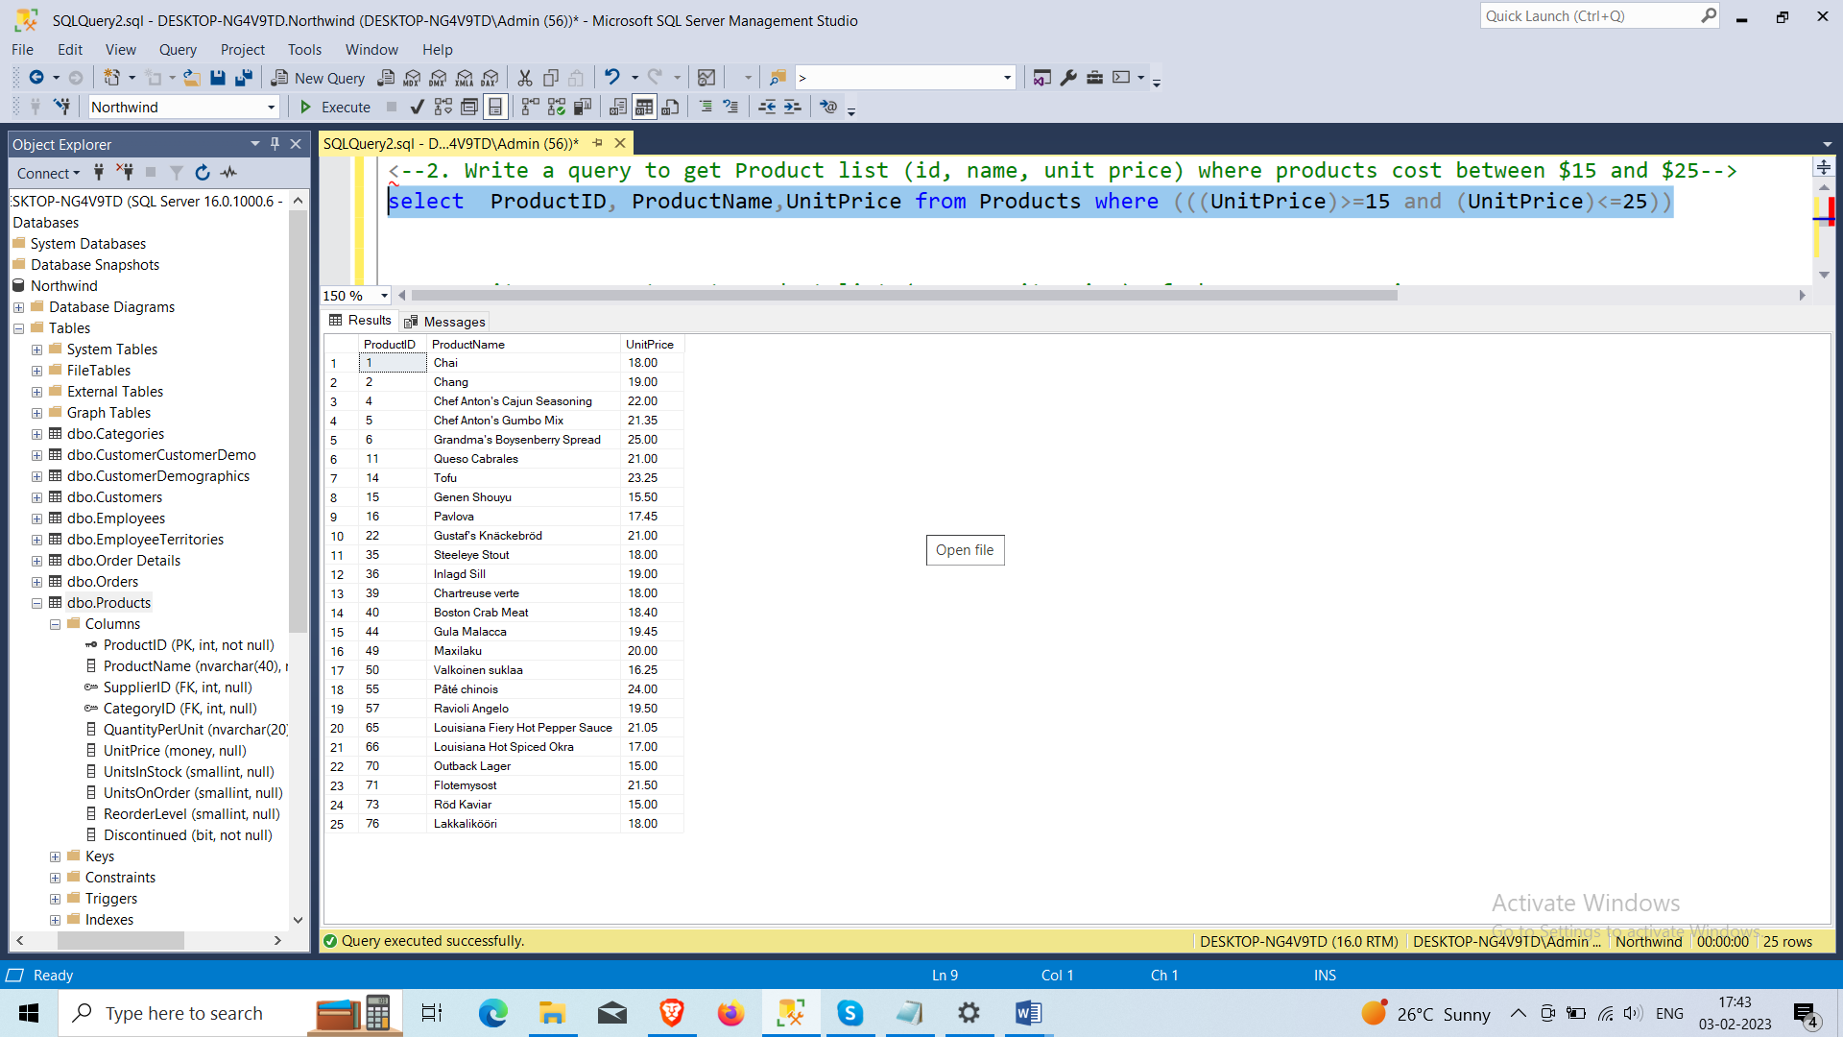

1. **Write a query to get Product list (name, unit price) of above average price.**

select productname, unitprice from Products where UnitPrice < (select avg(UnitPrice) from Products )

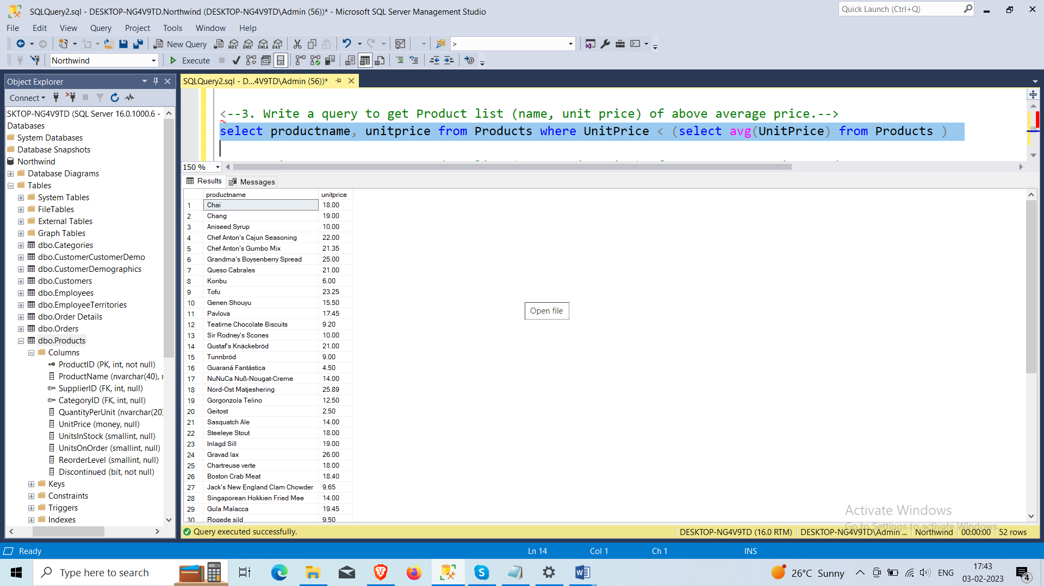

1. **Write a query to get Product list (name, unit price) of ten most expensive products.**

select top 10 ProductName, UnitPrice from Products order by UnitPrice desc;

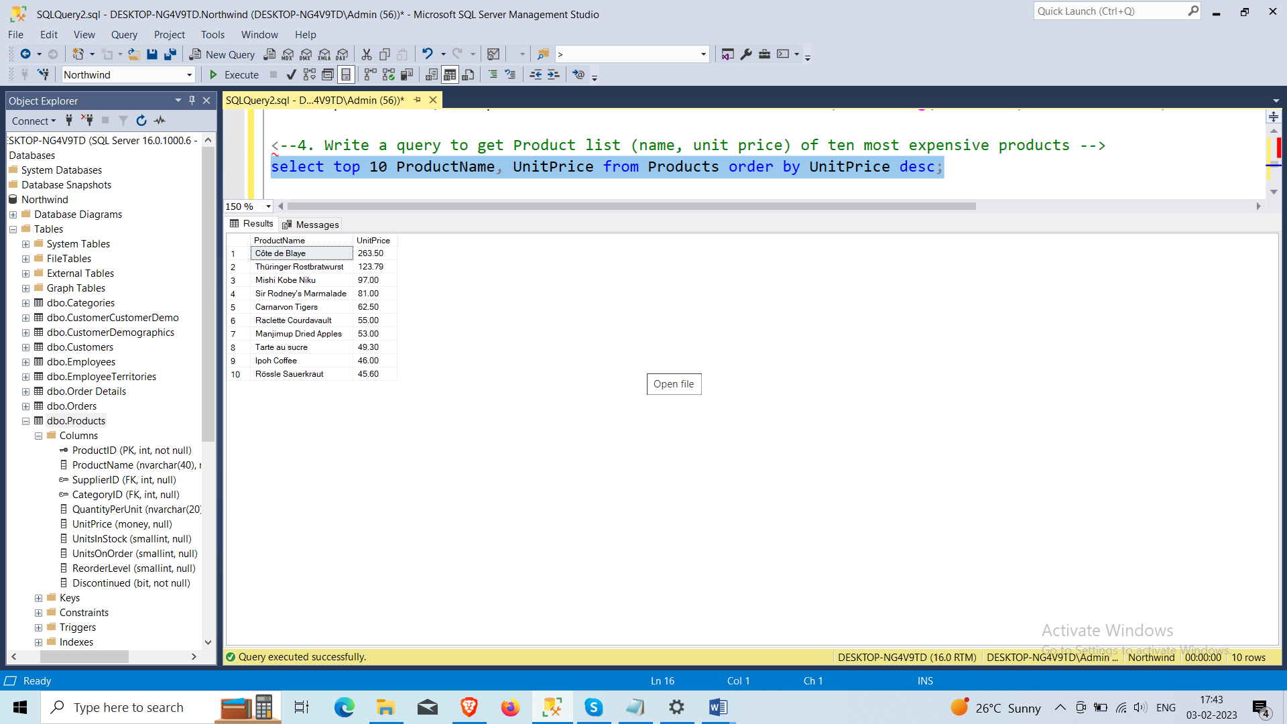

1. **Write a query to count current and discontinued products.**

select COUNT( ProductID), Discontinued from Products where ((Discontinued=1))group by (Discontinued);

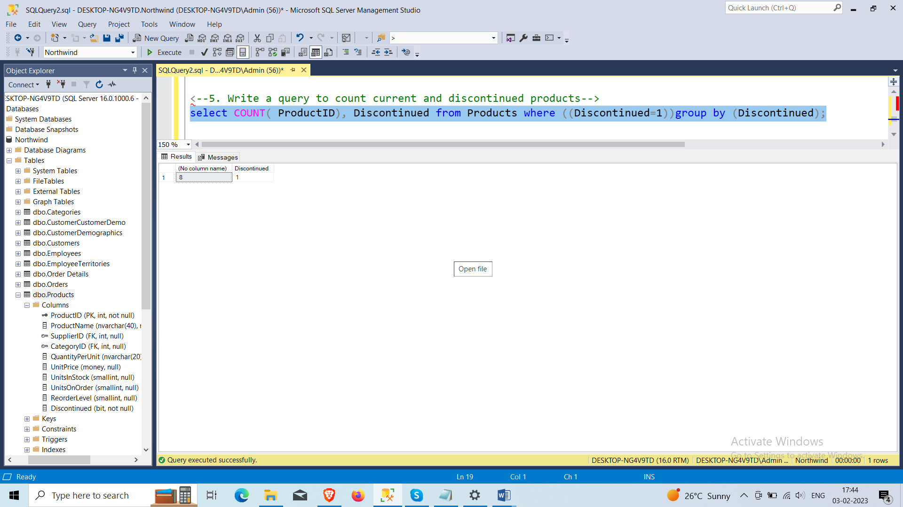

1. **Write a query to get Product list (name, units on order , units in stock) of stock is less than the quantity on order**

SELECT ProductName, UnitsOnOrder , UnitsInStock FROM Products WHERE ( ((UnitsInStock)<UnitsOnOrder));

